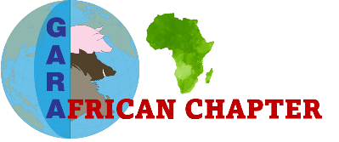

**GARA African Chapter**

**Annual report**

**March 2023/ February 2024**

**TABLE OF CONTENTS**

1. LIST OF ACRONYMS
2. GENERAL INFORMATION
3. FOREWORD BY THE CHAIRPERSON
4. STRATEGIC OVERVIEW
   1. VISION.
   2. MISSION.
5. COMMITTEE STRUCTURE
6. EVENTS
7. GAC MEMBERS RELEVANT PUBLICATIONS IN 2023
8. GAC MEMBERS RELEVANT PUBLICATIONS IN 2024
9. CHALLENGES
10. WAY FORWARD
11. CONTACT INFORMATION
12. **LIST OF ACRONYMS**

ARC Agricultural Research Council

* ARIM Agricultural Research Institute of Mozambique

ARS-USDA Agricultural Research Service of the United States Department of Agriculture

ASF African swine Fever

ASFV ASF virus

AU-IBAR African Union Inter African Bureau for Animal Resources

CVO Chief Veterinary Officer

ECOWAS Economic Community of West African States

EAC East African Community

FAO Food and Agriculture Organization

GARA The Global African Swine Fever Research Alliance

GAC GARA African Chapter

GF-TADs The Global Framework for the Progressive Control of Transboundary Animal Diseases

GU Gulu University

IAEA International Atomic Energy Agency

ILRI International Livestock Research Institute

MU Makerere University

MUST Mbarara University of Science and Technology

NARO National Agricultural Research Organization

NVRI National Veterinary Research Institute

SADC Southern African Development Community

SAPPO South African Pork Producers Organisation

SGE Standing Group of Experts

TADs Transboundary Animal Diseases

ToR Terms of Reference

UAC University of Abomey-Calavi

UP University of Pretoria

VLC Virtual Learning Centre

WOAH World Organisation of Animal Health

**2. GENERAL INFORMATION**

**Introduction and Overview of Global African Swine Fever (ASF) Research Alliance (GARA) African Chapter (GAC).**

As an outcome of the GARA Gap analysis workshop held in Kampala Uganda in February 2023, to encourage contextualization of the global objectives, south-south collaboration, and discourage working in silos for the control and prevention of African Swine Fever (ASF) in Africa, GARA African Chapter (GAC) was created. Presentations from several countries revealed there were disconnects amongst the research described as well as some duplication, and participants in the workshop agreed that more collaboration and cross-pollination would be highly beneficial. It was agreed that creating a formal platform for collaboration within GARA would provide the best way forward. The aim is to encourage scientists across borders and regions within countries to work together towards generating useful and contextualised information for the control and ultimate eradication of ASF in domestic pigs where necessary and possible in Africa. This is to be achieved in line with national regulations and guidelines, in collaboration with regional (i.e. SADC, ECOWAS, EAC) and international partners (i.e. WOAH, FAO, AU-IBAR, IAEA, ILRI), which may require interrogation as to their appropriateness to the African context. The terms of reference of GAC are:

1. To establish a network of experts in Africa on ASF and to facilitate cooperation, communication, and collaboration with existing networks.
2. To contextualise the goals and objectives of GARA to the African setting scientifically using best-fit strategies towards the control and eradication of the disease in conformity with the standards and guidelines of the WOAH.
3. To conduct research into various aspects of pig production, pig genetics, viruses, and vector ecology, spread and transmission of the virus, immunology, drivers and risk factors, socioeconomics of the disease and more in Africa.
4. To support vaccine development efforts given that all ASFV genotypes are found in Africa.
5. To emphasise the role of biosecurity along the value chain. This requires collaboration with a wide role of stakeholders, continued education, policy support, and monitoring by scientists to enable and encourage a shift in mindset.
6. To support the establishment and sharing of regional competencies/laboratories to provide key services, conduct research, and support disease outbreak investigation.
7. To work closely with FAO, WOAH, IAEA, ILRI, and AU-IBAR and to play a role in the development and implementation of the regional framework and regional ASF control strategy.

**3. FOREWORD BY THE CHAIRPERSON (Dr Pam Luka)**

The Global African swine fever Research Alliance (GARA) African Chapter (GAC) started as a branch of GARA in 2023 in Kampala, Uganda to bridge the gap and bring together researchers and scientists working on African swine fever (ASF) in Africa to explore the unique situation of the continent to answering the objectives of GARA to the landscape. It has been a year since it began, the beginning that can be described as an acorn and will go on to achieve success by preventing the spread of ASF for our good and that of food security.

We are indebted to all who have laboured in this area. The meeting in Kampala brought us onto a platform where we no longer need to work in silos but build bridges, linkages and collaborate across institutions and states because this disease does not know borders or boundaries. We have all worked in silos for a good time and it's time to abandon the “old tools” some of which originated through more of the North-south compared to the South-south collaborations. Therefore, breaking barriers and creating linkages in terms of working together for a better understanding of the complexity of our problems becomes imperative. The future can be said to be for those who work together, which is challenging but rewarding because of the perspectives that come with it. Surely, working in our little corners has brought us this far in understanding certain aspects of the virus, working together will help us move faster and provide solutions to our local farmers.

As we move into the future, there is a need to contextualise the global agenda/objectives to the African perspectives. Agreed, ASF evolved and was first reported in Africa and remained with us longer before becoming a “global” challenge. However, the African environment is different from that of Europe, Asia or the Americas because we have almost all the disease transmission cycles, more wild animals, and biological vectors compared to other continents. Our socio-cultural way of life is also different. To put a round peg in a round hole, researchers in Africa need to key into the uniqueness of our environment to design a solution fitting to the control and spread of ASF in Africa. Therefore, the group is here to cooperate and work with all stakeholders such as WOAH, FAO, STAR-IDAZ, AU-IBAR, etc in a harmonious way to concertedly tackle the challenge of ASF.

In addition, GAC has Scientists/Researchers with diverse capabilities and skills who have been funded and have the potential to generate knowledge and information in understanding the virus and its spread and the social life of the people that will proffer solutions that fit into the way of life of the people. This is necessary because whatever we scientists will suggest must agree with the way of life and the livelihoods of the people (beneficiaries).

**4. STRATEGIC OVERVIEW**

* 1. VISION.

To establish and sustain global research partnerships that will generate scientific knowledge and tools to contribute to the successful prevention, control and where feasible eradication of African Swine Fever (ASF).

* 1. MISSION.

A coordinated research network within the global research alliance (GARA) enabling the progressive control and eradication of ASF in domestic pigs in Africa.

1. **COMMITTEE STRUCTURE**

**EXECUTIVE COMMITTEE MEMBERS**

Pam Luka (NVRI), Peter Ogweng (MU), Ebanja Joseph Ebwanga, Carlos Quembo (ARIM).

**SCIENTIFIC COMMITTEE**

Michel Dione (ILRI), Folorunso O. Fasina (FAO), Charles Masembe (MU), Adeyinka Adedeji (MU), Peter Ogweng (MU).

**COMMUNICATION AND LOGISTICS COMMITTEE**

Rebecca Weka (MU), Samuel Mulondo (NARO), Tony Aliro (GU), Richard Ezinga (MUST), Joseph E. Ebanja.

**PROJECT AND COLLABORATION COMMITTEE**

Juanita van Emmenes (ARC), Marcel Casimir Ndongo (FAO), Carlos Quembo (ARIM), Mary-Louise Penrith (UP), Hans Ohouko (UAC), Elsa Lameira (ARIM).

1. **EVENTS**

**ORGANISATIONAL MEETINGS OF GAC**

**GARA AFRICA CHAPTER CONGRESS HELD ON 19TH OCTOBER 2023 VIRTUALLY**

This was the maiden General Assembly of the Chapter. The project and collaboration (P&C) committee presentation aimed at building capacity and collaboration to develop biosecurity and carry out compartmentalization training for farmers in endemic countries to see the opportunities for observing biosecurity to be able to trade. Congress was also informed that some of our members are trainers using the FAO virtual learning platform and links were made available for the group to access.

The Communication and Logistics (C&L) Committee presented their responsibilities to include guiding communications and logistical aspects of GAC, publicising international communications, and organising remote participation. They are to create a database of all members and make posters for all upcoming Congresses and other meetings.

**GARA AFRICA CHAPTER ANNUAL PLANNING MEETING WITH MEMBERS OF THE SCIENTIFIC COMMITTEE ON 15TH FEBRUARY 2024**

The scientific committee meeting focused on developing a work plan for ASF research for the GAC. However, discussion among members presented different ideas such as:

* Scientific presentations/ webinars every three months.
* Metadata sheet development for ASF sampling.
* Capacity development in:
* ASFV diagnostics
* Field epidemiology on ASF and other veterinary diseases.
* Biosecurity especially on compartmentalization.
* Genotyping and sequencing.
* Value chain studies.
* Newsletter publication on ASF outbreaks and Research in Africa.
* Incorporation of social scientists on the GAC team.

All these ideas were expected to be discussed with GAC members to refine and fine tune for a better implementation.

**WORKSHOP/CONFERENCES/CAPACITY BUILDING ACTIVITIES ORGANISED BY GAC**

**GARA AFRICA CHAPTER (GAC) WORKSHOP/GENERAL ASSEMBLY 30TH NOVEMBER 2023**

The GAC workshop brought together 59 members from diverse African Research Institutions, Universities, and animal disease control services. Guest representatives of collaborative institutions and Speakers included Karl Ståhl (Representative of GARA), Andriy Rozstalnyy (FAO), Casimir Ndongo (FAO), Gregorio Torres (WOAH), Hiver Boussini (AU-IBAR), Charles Lamien (Joint FAO-IAEA Lab), Edward Okoth (ILRI), Douglas Gladue (ARS-USDA) and Mary-Louise Penrith (UP).

Below a screenshot of meeting attendees:

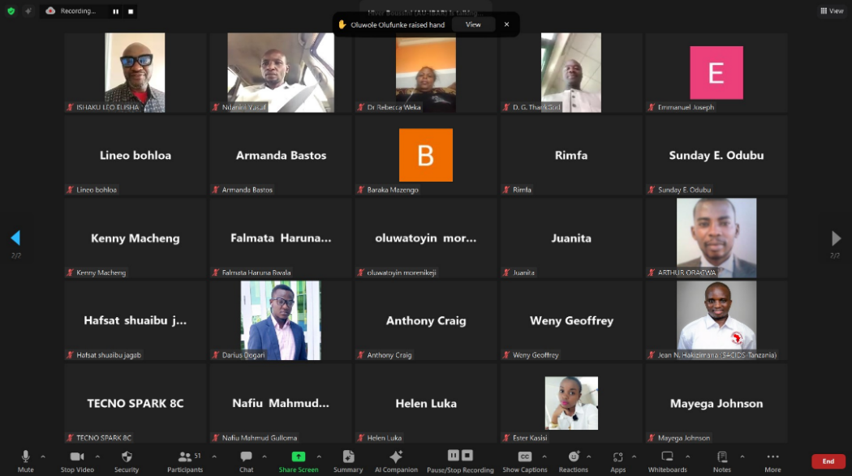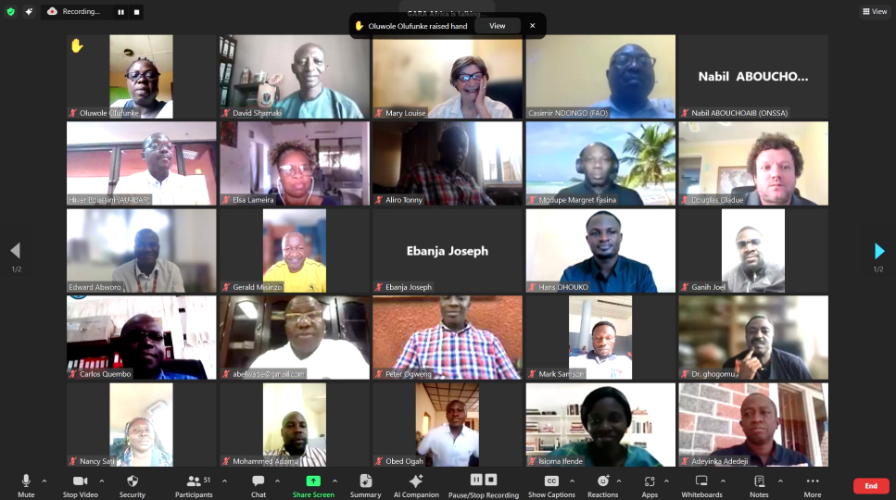

The meeting comprised of four major events including:

* A formal welcoming session dedicated to welcoming remarks from the GAC interim leading Committee and Karl Ståhl (representing the GARA President)
* An introductory session dedicated to a presentation of the background of GAC and a recall on the ASF Research Gap analysis as conducted in Kampala in February 2023
* A technical session dedicated to five presentations and discussion on the following topics:
* ASF control strategy by AU-IBAR, the leading institution on the continent responsible for the control of ASF and other TADs in Africa.
* Capacity development and differential diagnostic tools for ASF and other swine diseases by Joint FAO-IAEA Lab
* Principles of compartmentalization by WOAH
* On-farm Biosecurity and Progressive Management Pathway for Biosecurity by FAO
* ASF Vaccine Development: Progress and Prospects by ILRI and ARS-USDA
* Closing session consisting of a presentation on adopted GAC Action points and recommendations by GAC Team Member.

**FOLLOW-UP ACTIONS/RECOMMENDATIONS OF THE WORKSHOP**

**Follow-up Actions**

The GAC Interim Committee presented the action plan proposed by the three thematic subcommittees and adopted by the previous GAC General Assembly, which was discussed and approved for follow-up. These are collaborative activities that can be carried out either by GARA Africa or through the cooperation and development initiatives with competent agencies, scientific activities, and communication as follows:

* **Activity 1 (Policy and Strategy Proposed)**: Follow up on the GARA Gap Analysis Meeting in Kampala, Uganda, February 2023. Examine the gaps identified, prioritise those gaps, and propose a way forward to address the gaps. *Collaborators: GARA Main Group*
* **Activity 2 Policy and Strategy Proposed**: Update and inform members on the African Swine Fever Control Strategy for Sub-Saharan Africa, and explore GAC’s contribution to implementation, elaboration of the regional control programme and national action plans development/update. *Collaborators: AU-IBAR*
* **Activity 3 (Biosecurity for ASF):** Training of GARA Africa members on compartmentalization: *Collaborators: WOAH.* After the ASF Standing Group of Experts meeting for Africa in Abidjan in August 2023, the concept of compartmentalization was understood as crucial for the development of the swine industry in Africa and the participation of member countries in trade. The presentation was informative during the 3rd GAC General Assembly. However, it was recommended that a specific capacity-building session for GAC members aim at enabling them for further in-country training; *Collaborators: WOAH, SAPPO (South African Pork Producers Organisation)*
* **Activity 4 (Biosecurity for ASF):** Capacity building for GARA Africa members on the FAO Progressive Pathway for Biosecurity. The Progressive Management Pathway for Terrestrial Animal Biosecurity by FAO was seen as innovative by GAC. It is an opportunity for sound improvement of the concept and practices of biosecurity towards the efficient control of ASF in Africa, and the safer development of the swine industry. After the concise presentation at the GAC General Assembly, a more appropriate and dedicated training session was adopted as a priority with a more specific VLC or on-site course/training on biosecurity in the pig sector. *Collaborator: FAO, FAO Virtual Learning Centre (VLC)*
* **Activity 5 (Diagnosis)**: As part of the Gap Analysis, there was the need to identify and find ways to address the shortcomings of diagnostic laboratories and build capacity. Evaluation of the laboratory capacity in all the countries by experts from competent bodies (WOAH or IAEA). WOAH is in the process of identifying laboratories with the capacity to be reference laboratories. *Collaborators: IAEA, WOAH*
* **Activity 6 (Diagnosis):** Development of diagnostic tools for differential diagnosis of ASF and other swine diseases. During the workshop, the Joint FAO/ IAEA Lab demonstrated the innovative multiplex PCR tool developed and its availability. Thus, partnership should be explored for the implementation of these tools and appropriate techniques for swine diseases diagnosis. *Collaborators: IAEA, WOAH*
* **Activity 7 (Diagnosis):** Improve access and use of available point-of-care tests for ASF and advocate for their use for frontline diagnosis in member countries. This will improve disease reporting, control spread, and guide farmers in making informed decisions. *Collaborators: IAEA, FAO*
* **Activity 8 (Diagnosis):** Promotion of collaboration between laboratories in the region. Assistance of reference laboratories and laboratories with better capacity to laboratories with lower capacity should be explored and encouraged. Access to reagents, equipment, and training should be facilitated. Joint activities such as round-robin (proficiency) testing of samples should be undertaken to ensure the quality of laboratory services. *Collaborators: IAEA, WOAH, FAO*
* **Activity 9 (Communication and logistics)** Promotion of GAC:
* Exploration of training opportunities
* Creation and keeping an updated list of members (including names, emails, phone numbers, employing institution, area of research, ongoing research or to be done in future, etc.)
* Design and production of posters for the upcoming congress (collection of articles of ongoing work or other educative articles on African swine fever) in collaboration.
* Search for platforms and other avenues to promote the GARA Africa Chapter to the international community.
* Creation of email, LinkedIn profile, and Facebook profile for the GARA Africa chapter
* **Activity 10 (scientific**): organisation of bimonthly scientific presentations to discuss practical solutions for farmers, including biosecurity measures and identifying gaps.
* **Activity 11 (scientific)**: Prioritising ASF research based on gaps suggested. The following research areas suggested as priority are ASF vector research, ASF vaccine research, Research related to local breeds of pigs and ASF resistance, Socioeconomic impact of ASF on communities and livelihoods.
* **Activity 12 (resources)**: resources mobilisation for GAC activities implementation

Developing proposals to secure funding from potential donors and industry partners based on identified 2.

**Recommendations**

* **To AU-IBAR, ILRI, GAC, and other research institutions involved in ASF vaccine research**: Whatever vaccine is being developed for African use, should provide cross-protection between multiple genotypes.
* **To AU-IBAR:** Involve GAC in the validation process and implementation of the ASF regional strategy. Encourage participation of GAC in the development of the regional ASF control programme and the national ASF control plan development/update
* **To GAC:** GAC should expand and ensure representation in all the sub-regions and ASF-affected countries as well as any at risk. They should play the role of a specific ASF research network, bridge the gap between researchers and users of research outcomes, and continue monitoring in countries' ASF situation for better national ASF and ASFV genotype status knowledge.
* **To Africa GF-TADs (WOAH, FAO, AU-IBAR)**: Involvement of GARA in SGE beside other experts and CVOs.
* **To Africa ASF SGE**: the issue of compensation or insurance to be addressed to improve outbreak reporting for efficient control ASF outbreaks and ASFV spread in the Continent should be added in the next ASF SGE meeting agenda for discussion with CVOs and Experts, as well as modified stamping-out policy adapted to sub-Saharan Africa countries.
* **To WOAH and GAC**: organise a specific training to build capacity of GAC members to support compartmentalization in Africa.
* **To GAC**: Considering the importance of the concept, GAC is invited to make good use of available WOAH tools and recommendations on compartmentalization.
* **To FAO and GAC**: To organise specific training to build capacity of GAC members to customise the implementation of the Progressive Management Pathway for Terrestrial Animal Biosecurity in Africa context.
* **To FAO/IAEA and GAC**: Explore collaboration framework between FAO/IAEA and GAC, to create more capacity among African laboratories, to build capacity of GAC members in differential swine diseases using multiplex PCR techniques, and for technical support of GAC and national laboratories by IAEA.
* **To AU-IBAR, FAO/IAEA and GAC:** Explore collaboration framework to address the gap related to the lack of genomes of African ASFV genotypes in gene banks.
* **To USDA and vaccine development institutions**: Facilitate collaboration with production laboratories and field studies trials of the ASF Genotype II vaccine platforms which have proven to be consistently safe and efficient for ASF Europe/Asia virulent strain under farm conditions. African scientist recommends that adequate assessment of the vaccine in Africa be carried out against the numerous genotypes before commercialization in Africa.
* **To USDA, ILRI, GAC, AU-IBAR, and vaccine development institutions**: To collaborate on the several complexities associated with the ASF vaccines that need to be addressed through research: looking into the genomics that relates to immune responses, looking at all the issues around synergistic interactions among genes, persistent infection associated with attenuated vaccines, vaccines’ side effects and cross protection among genotypes. Among these, cross protection studies are needed to explore vaccines that can be protective against clusters of closely related genotypes in Africa.
* **AU-IBAR, ILRI, GAC, USDA, FAO, WOAH: a specific meeting between** GAC and each of the collaborating institutions for discussion and exploring a specific collaboration network for implementation of the above adopted action points.

**SCIENTIFIC MEETING WITH AFRICAN UNION – INTERBUREAU FOR ANIMAL RESOURCES (AU-IBAR) 16TH JANUARY 2024**

The meeting covered various strategies and challenges related to disease prevention and control in Africa. Key topics included the importance of evidence-based research, the role of smallholders in disease spread, the need for a specific platform for their pigs, the challenges of biosecurity and capacity development, the outcome of a strategy discussion, the importance of improved reporting and collaboration, organising and representing various sub-regions in Africa, and the formation of a specific framework involving decision makers and various sectors. The team also discussed the importance of unity, collaboration, and validation of their actions by their leadership. Dr Hiver Boussini, Dr Pam Luka, Marcel Casimir Ndongo and Peter Ogweng attended this meeting.

**GARA AFRICA CHAPTER MEETING WITH FAO AND WOAH REPRESENTATIVE 7TH FEBRUARY 2024**

The meeting focused on collaboration and the terms of reference (ToR) for the Global African swine fever Research Alliance (GARA) African Chapter (GAC). The FAO representative emphasised the need for partnership and collaboration frameworks, while the GAC representatives highlighted the disconnect and lack of collaboration and networking among African researchers working on ASF. Participants discussed the importance of working collectively with various stakeholders to have a more significant impact on ASF control in Africa. The discussion also addressed the need for prioritising research efforts and informing the SGE about the work being done in Africa, highlighting the significant role of researchers in shaping the global initiative and sharing critical information to guide national authorities in disease control and prevention. This would also ensure the usefulness of research initiatives. The speakers emphasised the importance of complementarity and collaboration in running the GAC effectively.

The meeting concluded with plans to review the terms of reference (TOR), hold a general assembly meeting, and develop a website to improve communication. Following GARA leadership advice, participants explored the feasibility of hosting GARA-Africa's website separately outside the parent body due to administrative challenges. They also discussed the idea of linking to other organisations' websites and the complexities associated with it. The meeting ended with expressions of appreciation and well wishes for a good evening. Dr Casimir Ndongo (FAO), Dr Viola Chemis (WOAH), Dr Pam Luka (GAC) and Dr Joseph Ebanja (GAC) attended the meeting.

1. **GAC MEMBERS RELEVANT PUBLICATIONS IN 2023**

Penrith, M.-L., van Heerden, J., Pfeiffer, D.U., Oļševskis, E., Depner, K., Chenais, E. 2023. Innovative research offers new hope for managing African swine fever better in resource-limited smallholder farming settings: a timely update. *Pathogens*, 12, 355. doi: 10.3390/pathogens12020355.

Jori, F., Bastos, A., Boinas, F., van Heerden, J., Heath, L., Jourdan-Pineau, H., Martinez Lopez, B., Pereira de Oliveira, R., Pollet, Y., Quembo, C., Rea, K., Simulundu, E., Taraveau, F., Penrith, M.-L. 2023. An updated review of *Ornithodoros* ticks as reservoirs of African swine fever in Sub-Saharan Africa and Madagascar. *Pathogens*, 12, 469. doi: 10.3390/pathogens.12030469.

Palencia, P., Blome, S., Brook, R.K., Ferroglio, E., Jo, Y.-S., Linden, A, Montoro, V., Penrith, M.-L., Plal, R., Vivente, V., Viltrop, A., Gortázar, C. 2023. Tools and opportunities for African swine fever control in wild boar and feral pigs: a review. *European Journal of Wildlife Research*, 69, 69 doi: 10.1007/s10344-023-01696-w.

Penrith, M.-L., Okoth, E., Heath, L. 2023. Editorial: Special issue: “African swine fever and other swine viral diseases in Africa”. *Viruses*, 15, 1438. doi: 10.3390/v15071438.

Adeola AC, Luka PD, Jiang XX, Cai ZF, Oluwole OO, Shi X, Oladele BM, Olorungbounmi TO, Boladuro B, Omotosho O, Okoro VMO, Dawuda PM, Olaogun SC, Sanke OJ, Xie HB, Bishop RP, Han J, Li J, Zhang YP, Peng MS. 2023. Target capture sequencing for the first Nigerian genotype I ASFV genome. *Microb Genom*. doi: 10.1099/mgen.0.001069.

Ogundijo OA, Omotosho OO, Al-Mustapha AI, Abiola JO, Awosanya EJ, Odukoya A, Owoicho S, Oyewo M, Ibrahim A, Orum TG, Nanven MB, Bolajoko MB, Luka P, Adeyemo OK, 2023. A multi-state survey of farm-level preparedness towards African swine fever outbreak in Nigeria. *Acta Tropica*. 246. https://doi.org/10.1016/j.actatropica.2023.106989.

Dinhobl, M., Spinard, E., Tesler, N., Birtley, H., Signore, A., Ambagala, A., Masembe, C., Borca, M.V. and Gladue, D.P., 2023. Reclassification of ASFV into 7 Biotypes Using Unsupervised Machine Learning. *Viruses*. 16(1), p.67.

Spinard E, Dinhobl M, Tesler N, Birtley H, Signore AV, Ambagala A, Masembe C, Borca MV, Gladue DP. 2023. A Re-Evaluation of African Swine Fever Genotypes Based on p72 Sequences Reveals the Existence of Only Six Distinct p72 Groups. *Viruses.* 15(11):2246. doi: 10.3390/v15112246.

Aliro T, Odongo W, Ståhl K, Dione MM, Okello DM, Masembe C, Chenais E. 2023. Actions and perceived impact of African swine fever control measures along the smallholder pig value chain in Uganda. *Trop Anim Health Prod*. 55(6):410. doi: 10.1007/s11250-023-03828-5.

Ambagala A, Goonewardene K, Lamboo L, Goolia M, Erdelyan C, Fisher M, Handel K, Lung O, Blome S, King J, Forth JH, Calvelage S, Spinard E, Gladue DP, Masembe C, Adedeji AJ, Olubade T, Maurice NA, Ularamu HG, Luka PD. 2023. Characterization of a Novel African Swine Fever Virus p72 Genotype II from Nigeria. *Viruses*. 15(4):915. doi: 10.3390/v15040915.

Kabuuka T, Mulindwa H, Bastos ADS, van Heerden J, Heath L, Fasina FO. 2023. Retrospective Multi-Locus Sequence Analysis of African Swine Fever Viruses by “PACT” Confirms Co-Circulation of Multiple Outbreak Strains in Uganda. *Animals*. 14(1):71. https://doi.org/10.3390/ani14010071.

Mthombeni RF, Bastos AD, van Schalkwyk A, van Emmenes J, Heath L. 2023. Phylogenomic Comparison of Seven African Swine Fever Genotype II Outbreak Viruses (1998-2019) Reveals the Likely African Origin of Georgia 2007/1. *Pathogens.* 12(9):1129. doi: 10.3390/pathogens12091129.

Mazloum A, van Schalkwyk A, Chernyshev R, Igolkin A, Heath L, Sprygin A. 2023. A Guide to Molecular Characterization of Genotype II African Swine Fever Virus: Essential and Alternative Genome Markers. *Microorganisms.* 11(3):642. doi: 10.3390/microorganisms11030642.

Masembe C, Adedeji AJ, Jambol AR, Weka R, Muwanika V, Luka PD. 2023. Diversity and emergence of new variants of African swine fever virus Genotype I circulating in domestic pigs in Nigeria (2016-2018). *Vet Med Sci.* 9(2):819-828. doi: 10.1002/vms3.988.

Spinard E, Rai A, Osei-Bonsu J, O'Donnell V, Ababio PT, Tawiah-Yingar D, Arthur D, Baah D, Ramirez-Medina E, Espinoza N, Valladares A, Faburay B, Ambagala A, Odoom T, Borca MV, Gladue DP. 2023. The 2022 outbreaks of African Swine Fever Virus Demonstrate the First Report of Genotype II in Ghana. *Viruses*. 15(8):1722. doi: 10.3390/v15081722.

Hakizimana JN, Yona C, Makange MR, Kasisi EA, Netherton CL, Nauwynck H, Misinzo G. 2023. Complete genome analysis of African swine fever virus genotypes II, IX and XV from domestic pigs in Tanzania. *Sci Rep.*13(1):5318. doi: 10.1038/s41598-023-32625-1.

1. **GAC MEMBERS RELEVANT PUBLICATIONS IN 2024**

Penrith, M.-L., van Emmenes, J., Hakizimana, J.L., Heath, L., Kabuuka, T., Misinzo, G., Odoom, T., Wade, A., Zerbo, H.L., Luka, P.D. 2024. African swine fever diagnosis in Africa: Challenges and opportunities. *Pathogens*, 13, 296 doi: 10.3390/pathogens13040296.

Fasina, F.O., Mtui-Malamsha, N., Nonga, H.E., Ranga, S., Sambu, R.M., Majaliwa, J., Kamani, E., Okuthe, S., Kivaria, F., Bebay, C., Penrith, M.-L. 2024. Semiquantitative risk evaluation reveals drivers of African swine fever virus transmission in smallholder pig farms and gaps in biosecurity, Tanzania. *Veterinary Medicine International,* 2024, Article ID 4922141. doi:10.1155/2024/4929141.

Penrith, M.-L., Mo, Y., Su, Z., Hoang, D.V., Pogranichniy, R.M., Balaban-Oglan, D.-A., Li, Y., Wang, K., Cai, X., Shi, J. 2024. 2023 International workshop on African swine fever: Critical issues that need to be addressed for ASF control. *Viruses*, 16, 4. doi: 10.3390/v16010004.

Balboa RF, Bertola LD, Brüniche-Olsen A, Rasmussen MS, Liu X, Besnard G, Salmona J, Santander CG, He S, Zinner D, Pedrono M, Muwanika V, Masembe C, Schubert M, Kuja J, Quinn L, Garcia-Erill G, Stæger FF, Rakotoarivony R, Henrique M, Lin L, Wang X, Heaton MP, Smith TPL, Hanghøj K, Sinding MS, Atickem A, Chikhi L, Roos C, Gaubert P, Siegismund HR, Moltke I, Albrechtsen A, Heller R. 2024. African bushpigs exhibit porous species boundaries and appeared in Madagascar concurrently with human arrival. *Nat Commun*. 15(1):172. doi: 10.1038/s41467-023-44105-1.

Spinard, E., Wade, A., Unger, H., Robert, N., Mayega, F.J., Sreenu, V.B., Da Silva Filpe, A., Mair, D., Borca, M.V., Gladue, D.P. and Masembe, C. 2024. Near-complete genome sequences of multiple genotype 1 African swine fever virus isolates from 2016 to 2018 in Cameroon. Microbiology Resource Announcements, 13(4), pp.e00978-23.

Wang, L., Ganges, L., Dixon, L.K., Bu, Z., Zhao, D., Truong, Q.L., Richt, J.A., Jin, M., Netherton, C.L., Benarafa, C., Summerfield, A., Weng, C., Peng, G., Reis, A.L., Han, J., Penrith, M.-L., Mo, Y., Su, Z., Hoang, D.V., Pogranichniy, R.M., Balaban-Oglan, D.A., Li, Y., Wang, K., Cai, X., Shi, J. 2024. 2023 International African swine fever workshop: Critical issues that need to be addressed for African swine fever control. *Viruses*, 16, 4. doi: 10.3390/v16010004.

Goatley, L.C., Freimanis, G.L., Tennakoon, C., Bastos, A., Heath, L., Netherton, C.L. 2024. African swine fever virus NAMP1/95 is a mixture of genotype I and genotype VIII viruses. *Microbiology Resource Announcements*, doi: 10.1128/mra.00067-24.

Goatley LC, Freimanis G, Tennakoon C, Foster TJ, Quershi M, Dixon LK, Batten C, Forth JH, Wade A, Netherton C. 2024. Full genome sequence analysis of African swine fever virus isolates from Cameroon. *PLoS One*. 19(3):e0293049. doi: 10.1371/journal.pone.0293049.

1. **CHALLENGES**

2023 GARA Gap Analysis has several challenges identified. https://www.ars.usda.gov/gara/gappresentations2023.htm

1. **WAY FORWARD**

* African Newsletter on ASF
* ASF webinars
* The GARA Africa Executive Committee to develop a website for GARA Africa and ensure it is linked to the main GARA website.

1. **CONTACT INFORMATION**

LinkedIn:  https://www.linkedin.com/in/gara-african-chapter-522221293/

Facebook:  https://www.facebook.com/profile.php?id=61551475537116

Website: https://www.garaafrica.com